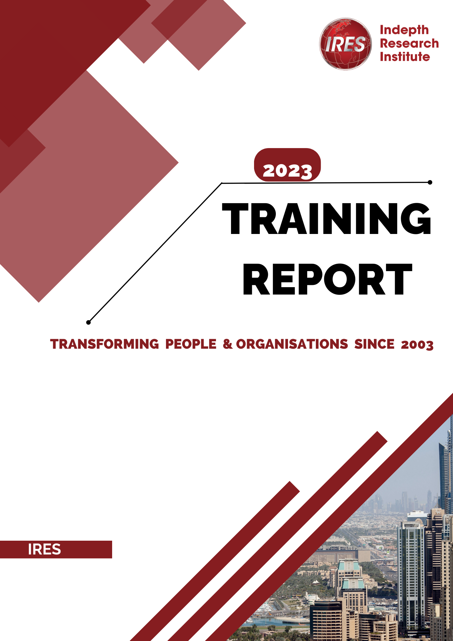

PREPARED FOR: Indepth Research Institute
ORGANIZATION: (participant’s Org)
PRESENTED BY: Moses Kurui
DATE: 28/2/2025

2024

INTRODUCTION TO THE COURSE.
ABOUT THE PARTICIPANT | Zukile Sokapase
ORGANIZATION AND JOB ROLE | PHD Student
RATIONALE FOR THE TRAINING | Gain Knowledge in using Stata for panel data analysis.

Course Objectives

COURSE OBJECTIVES

TRAINING METHODOLOGY
TRAINING DELIVERY METHODS USED

TRAINING PROGRAM
OPENING OF THE WORKSHOP
TRAINING PROGRAM

The Panel Data Analysis using Stata workshop begins with an introductory session to set the stage for the training. The facilitator welcomes participants and provides an overview of the course objectives, structure, and expectations. Attendees introduce themselves, sharing their backgrounds and experience with panel data analysis to foster engagement and networking.
The session then transitions into an introduction to panel data, explaining its significance in economic, financial, and social research. Key concepts such as cross-sectional vs. time-series data and the advantages of panel data analysis are discussed. Participants also receive a brief demonstration of Stata, including an overview of its interface, commands, and data management capabilities.
To conclude the opening session, participants engage in a hands-on exercise, importing and exploring a sample panel dataset in Stata. This interactive approach ensures that attendees are comfortable with the software before diving into more advanced topics.

TRAINING SESSION MODULES

Module 1: Introduction to Panel Data Analysis and Stata Basics
- Overview of panel data and applications
- Data importing, management, and manipulation in Stata
- Understanding fixed and random effects
- Hands-on exercise in panel data management
Module 2: Fixed and Random Effects Models
- Estimation and interpretation of fixed and random effects models
- Selection of appropriate models using the Hausman test
- Case study on firm-level data analysis
Module 3: Dynamic Panel Data Models
- Introduction to difference and system GMM
- Addressing endogeneity and autocorrelation
- Practical exercise on building dynamic models in Stata
Module 4: Testing for Autocorrelation, Endogeneity, and Model Diagnostics
- Detecting and correcting for econometric issues in panel data
- Model diagnostics and interpretation
- Case study on endogeneity testing in economic models
Module 5: Advanced Applications of Panel Data Analysis
- Application of panel data methods in economics, finance, and policy
- Practical exercises with real-world data
- Final project: Building and interpreting a panel data model using organizational data

CLOSING OF THE WORKSHOP

The Panel Data Analysis using Stata workshop concluded with a wrap-up session that reinforced key takeaways from the training. The facilitator summarized the main topics covered, including fixed and random effects models, dynamic panel data models, and techniques for handling endogeneity and autocorrelation. The attendee reflected on their learning experience and discussed how they planned to apply the skills acquired in their professional work.
A Q&A session followed, allowing the attendee to seek clarification on any remaining doubts. They also shared insights and challenges they had encountered during the hands-on exercises.
To formally close the workshop, the facilitator provided additional resources for continued learning, such as recommended readings, Stata documentation, and advanced training opportunities. A certificate of completion was presented, and the attendee provided feedback on the course.
The session ended with final remarks from the instructor, ensuring that the attendee left with both technical expertise and confidence in applying panel data analysis using Stata.

TRAINING RESULTS

During the Panel Data Analysis using Stata workshop, the attendee successfully applied theoretical concepts to real-world datasets through hands-on exercises. The practical results included:
- Panel Data Management – The attendee imported, cleaned, and structured panel data in Stata, ensuring proper formatting for analysis. They practiced handling missing values, reshaping data, and generating summary statistics.
- Fixed and Random Effects Models – Using sample firm-level data, the attendee estimated and interpreted fixed effects (FE) and random effects (RE) models. They performed the Hausman test to determine the appropriate model for a given dataset.
- Dynamic Panel Data Models – The attendee implemented Generalized Method of Moments (GMM) estimators, applying difference GMM and system GMM techniques to account for endogeneity in panel data.
- Diagnostic Testing – The attendee conducted tests for autocorrelation, heteroscedasticity, and endogeneity, applying corrections where necessary. They successfully used instrumental variable approaches to address endogeneity.
- Final Project – As a culminating exercise, the attendee built and interpreted a complete panel data model using a provided dataset. They generated insights from their analysis and effectively communicated results using Stata’s output and visualization tools.

TRAINING PURPOSE

The Panel Data Analysis using Stata training was designed to equip participants with the skills necessary to analyze datasets that combine both time-series and cross-sectional dimensions. The key objectives of the training were to:
- Develop a Strong Understanding of Panel Data Analysis – The training aimed to provide a solid foundation in panel data concepts, including fixed effects, random effects, and dynamic panel models.
- Enhance Practical Skills in Stata – Participants were trained to efficiently manage, manipulate, and analyze panel datasets using Stata’s advanced features. Hands-on exercises ensured practical application of theoretical knowledge.
- Improve Data-Driven Decision-Making – By mastering panel data techniques, the training enabled participants to draw meaningful insights, assess trends, and support economic, financial, and policy-related decisions.
- Address Common Econometric Issues – The course focused on solving challenges such as endogeneity, autocorrelation, and heteroscedasticity, ensuring that participants could build robust and reliable econometric models.
- Enable Application of Advanced Panel Data Techniques – Through real-world case studies and exercises, the training helped participants apply panel data methods to research and professional projects, enhancing their analytical capabilities.

TRAINING METHODOLOGY

The Panel Data Analysis using Stata training was conducted using a practical, hands-on approach, ensuring that the attendee gained direct experience in applying panel data techniques. The methodology included:
- Interactive Coding Sessions – The training focused on in-class live coding in Stata, where the attendee practiced importing, managing, and analyzing panel data in real time.
- Step-by-Step Demonstrations – The facilitator provided guided demonstrations of panel data techniques, including fixed and random effects models, dynamic panel modeling, and diagnostic testing. The attendee followed along by coding simultaneously in Stata.
- Real-World Examples – The training incorporated case studies and datasets from economic, financial, and social research to illustrate practical applications of panel data analysis.
- Hands-On Exercises – Each module included practical exercises where the attendee applied the concepts learned, tested models, and interpreted results using Stata’s output and visualization tools.
- Problem-Solving Approach – The facilitator guided the attendee through common econometric issues such as endogeneity, autocorrelation, and heteroscedasticity, using coding examples to apply corrections and improve model accuracy.
- Final Practical Project – The attendee worked on a mini-project, building a panel data model using a real dataset, applying the techniques learned throughout the course.

TRAINING ENVIRONMENT

The training was conducted online.

CONCLUSIONS AND RECOMMENDATIONS

Conclusion.

The Panel Data Analysis using Stata training successfully equipped the attendee with the necessary skills to manage and analyze panel data using Stata’s advanced features. Through a practical, hands-on approach, the attendee gained experience in coding, model estimation, and troubleshooting common econometric challenges such as endogeneity and autocorrelation.
By working with real-world datasets, conducting fixed and random effects analyses, and applying dynamic panel models, the attendee developed a strong foundation in panel data techniques. The final project allowed them to integrate their learning and apply it to a complete panel data analysis workflow.
Overall, the training provided valuable insights into data-driven decision-making, enhancing the attendee’s ability to conduct robust econometric analyses. With these skills, they are now better prepared to apply panel data methods in research, finance, economics, and policy analysis.

Trainer.
Moses Kurui

Participant.

Zukile Sokapase

LESSONS LEARNT FROM THE TRAINING

APPENDICES

List of Participants

Name | Country | Designated Role | Telephone No | Email Address
Zukile Sokapase | South Africa | Participant |  | z.sokapase@gmail.com
Moses Kurui | Kenya | Trainer | 0703135975 | mosesriku@gmail.com

